 

<https://centralwestoht.ca/nlot/>

**Recommended Positions during Tube Feedings**

* 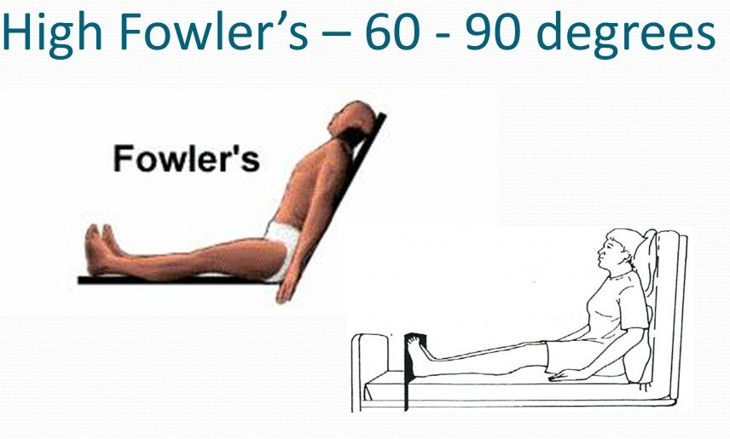Propped up in bed or on a couch in a half sitting position with the head raised at least 30 degrees during and after feeds for at least 1 hour
* Sitting up in a chair
* **Never while lying flat**
* Should **STOP feeds** when patient lying flat during personal care
* Proper positioning reduces the risk for ASPIRATION

**Semi-Fowler’s Position (Head of Bed to 30⸰-45⸰)**

